**MySQL DAY 1 (20-SEP-2023)**

CREATE DATABASE learningmysql;

USE learningmysql;



CREATE TABLE employee(empid int,name varchar(40));

DESC employee;

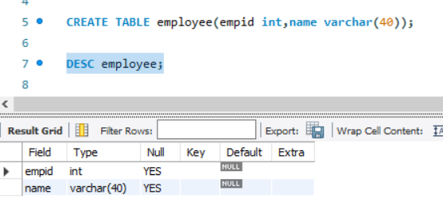

INSERT INTO employee(empid,name) VALUE(1008822,'NITIN');

INSERT INTO employee VALUE(1008830,'AKSHAY'),(1008820,'NIRAJ');

SELECT * FROM EMPLOYEE;

create table shirts (name varchar(30),size enum('xsmall','small','medium','large'));

insert into shirts values('POLO','small');

insert into shirts values('corcs','large');

insert into shirts values('JP','asdf');

create table member (Member_Id int(5) primary key,Member_Name varchar(20),Member_address varchar(10),Acc_Open_Date date,Membership_type enum('Lifetime','Annual','Half Yearly','Quarterly'),Fees_paid int(5),Max_Books_Allowed int(2),Penalty_Amount double);

-- INSERT INTO MEMBER VALUE(1,'NITIN','JALGAON',)

show databases;

select * from shirts;

create table book(Book_No int,Book_Name varchar(30),Author varchar(20),Cost int,Category varchar(10));

insert into book values(101,'Let us C','Denis Ritchle',450,'System'),(102,'Oracle-Complete Ref','Loni',550,'Database'),(103,'Mastering','Loni',250,'Database'),(104,'PL SQL-Ref','Scott Urman',750,'Database');

#1 Select all the records.

select * from book;

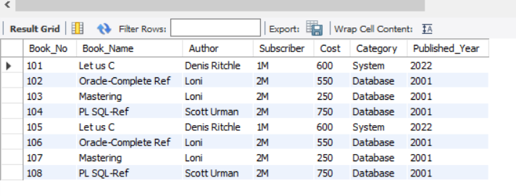

#2 Select records whoes cost between >=500 and <=700

select * from book where Cost>=500 and Cost<=700;

#3 Find record with book name staring with O letter

select * from book where Book_Name like 'O%';

#4 find records whose cost is < avg cost

select * from book where Cost<(select avg(Cost) from book);

#5 create new table with same structure

create table booknew like book;

select * from booknew;

insert into booknew values(105,'Let us C','Denis Ritchle',450,'System'),(106,'Oracle-Complete Ref','Loni',550,'Database'),(107,'Mastering','Loni',250,'Database'),(108,'PL SQL-Ref','Scott Urman',750,'Database');

#6 create new table as copy of books

create table bookstr as select * from book;

select * from bookstr;

#7 create new table with database as category

Create table onlydatabase as (select * from book where Category = 'Database');

select * from onlydatabase;

#8 find record with max cost

select * from book where Cost=(select max(Cost) from book);

#9 find record with min cost

select * from book where Cost=(select min(Cost) from book);

#10 find name of the author who has published more than one book

select Author from book group by Author having count(Book_Name)>1;

#11 Update cost of book (old +150) where book name is let us C.

SET SQL_SAFE_UPDATES = 0;

UPDATE book SET Cost=Cost+150 WHERE Book_Name like 'Let us C';

select * from book;

#12 select book name under category of Databse only

select Book_Name from book where Category = 'Database';

#13 select book name, cost under category(Databse,System)

select Book_Name, Cost from book where Category = 'Database' or Category = 'System';

#14 select book records where cost is less than 500

SELECT * FROM book WHERE Cost < 500;

#15 Alter table add new column published year

ALTER TABLE book ADD Published_Year Int;

update book set Published_Year=2001 where Category='Database';

update book set Published_Year=2022 where Category='System';

Select * from book;

#16 Alter table add subscriber after author

ALTER TABLE book ADD Subscriber varchar(20) AFTER Author;

update book set Subscriber='2M' where Category='Database';

update book set Subscriber='1M' where Category='System';

Select * from book;

